2023
Winners of the March 2023 Competition:
Senior Band: George Watson’s School
Intermediate Band: George Heriot’s School
Senior Piping: A Crockett, Dollar Academy
Intermediate Piping: H Kesterton, George Heriot’s School
Junior Piping: R Cairns, George Heriot’s School
Senior Drumming: E Sommerville, George Watsons’ School
Junior Drumming: T MacAndrew, Mearns Academy School
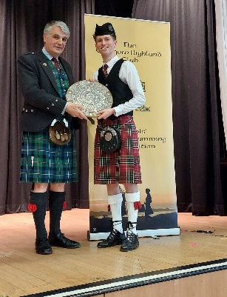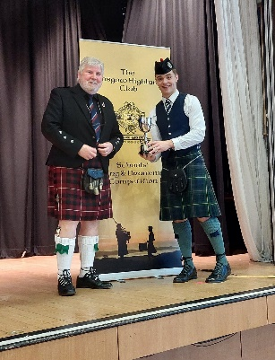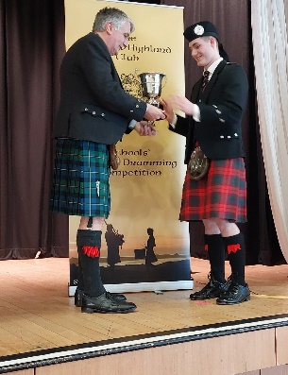
Senior Band 2023 Junior Band 2023 Senior Piping 2023

