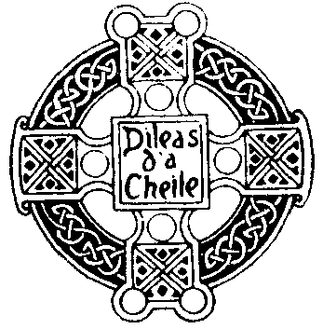THE GLASGOW HIGHLAND CLUB

Termcard 2020/21

2020
Monday 5th October at 6.45 pm
at The Glasgow Art Club
Informal dinner
Followed at 8.00 pm by
138th ANNUAL BUSINESS MEETING

Monday, 23rd November at 6.45pm for 7:15pm
at The Glasgow Art Club

FIRST HOUSE DINNER
Guests encouraged

Friday, 4th to Sunday 6th December
at the Kilfinan Hotel, Loch Fyne

PIOBAIREACHD SEMINAR
Participation in all or of any part very welcome

2021
Monday, 8th February, 2020 at 6.45pm for 7:15pm
at The Glasgow Art Club

SECOND HOUSE DINNER
Guests encouraged

Thursday 20th February 2020 7.30–9.30pm
at Glasgow High School FP Club Pavilion

AT HOME DANCE PRACTICE
Informal, fun and easy

Friday, 26th February, 2020 at 7.15 pm
in the Glasgow Marriott Hotel, Argyle Street.

AT HOME
Grand Highland Ball, all guests welcome

Saturday 6th March 2021 from 9.00am
At the College of Piping, Otago St, G12 8YH

Glasgow Uist & Barra Piping Competition
Piobaireachd prize sponsored by the Club

xxxxxxx March 2021 7:00 for 7:30pm
at The Glasgow Art Club

LECTURE NIGHT

All guests welcome

Sunday xxxx March, 2021 at 9:00 am to 3:00pm
at Hutchesons’ Grammar School

SCHOOLS’ PIPE BAND AND SOLO COMPETITION
Members required for (undemanding) Stewarding

Tuesday 23rd March, 2021 at 7:30pm
at Glasgow High School Club Pavilion

Club Internal Piping Competition 1st Night
2/4 march, strathspey, 6/8
Pipers of all standards encouraged

Tuesday 30th March, 2021 at 7:30pm
at Glasgow High School Club Pavilion

Club Internal Piping Competition 2nd Night
Piobaireachd, slow air, jig
Pipers of all standards encouraged

Saturday xxxxxxxxx 2021 7:00pm to 11:30pm

AWAY WEEKEND
In the Royal Hotel, Dunkeld
(All Guests welcome)

Friday xxxxx 7.00 for 7.30pm
At RSPS Rooms, Rose Street South
VISIT TO ROYAL SCOTTISH PIPERS’ SOCIETY
A night of piping and banter with our good friends

Monday, 4th October 2021, at 6.45 pm
at Glasgow Art Club
DINNER (Members only)
Followed at 8.15 pm by
139th ANNUAL BUSINESS MEETING

